Alexander Baldree
06/03/26
1.2 Assignment
CSD430

GitHub Link:
https://github.com/Panda-Alex21687/CSD430

GitHub with GitIgnore and Readme:
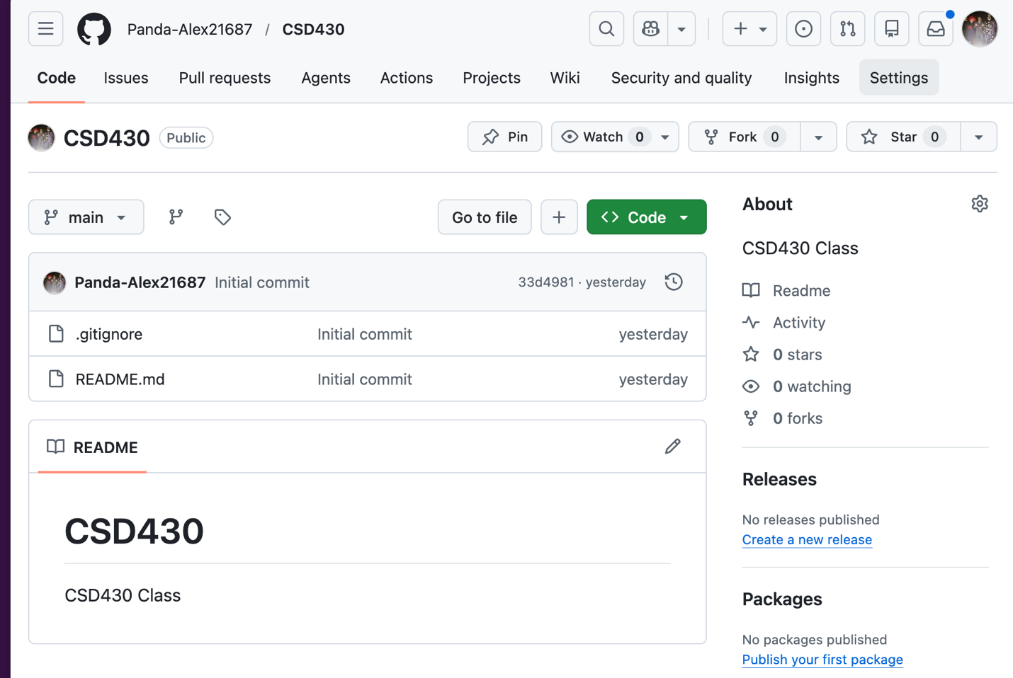

GitHub Local Folder:
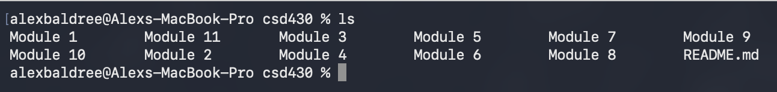
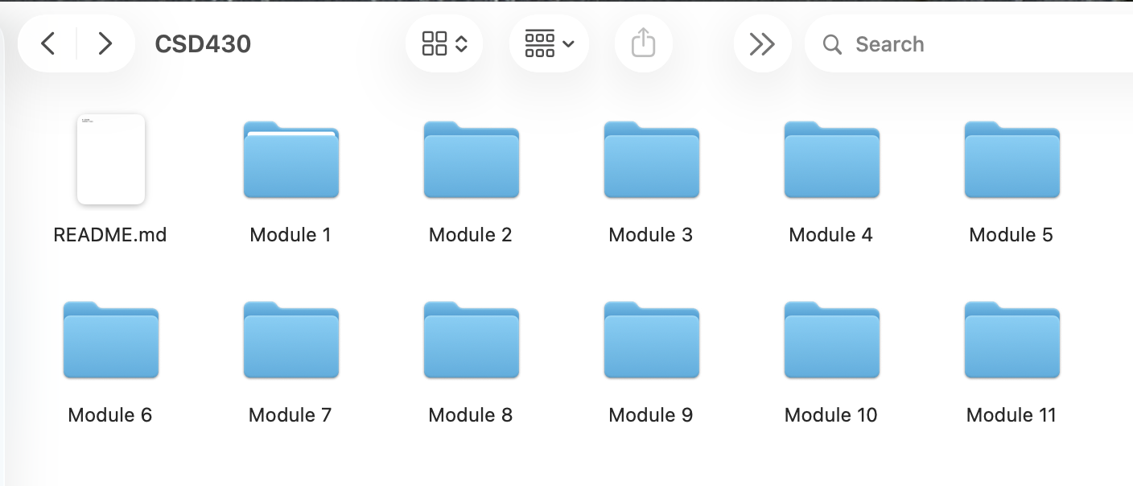

Git Remote -v: Showing connected to GitHub:
